E-COMMERCE BUSINESS PERFORMANCE ANALYSIS REPORT

Domain: Data Science & Analytics
Project Assignment: Week 4 Capstone Submission (Option 4)
Intern Name: Suriyapriya K

1. PROJECT OVERVIEW
1.1 Introduction
In the modern retail ecosystem, e-commerce platforms generate massive volumes of transactional data daily. Understanding this data is vital for tracking growth, optimizing inventory, and maximizing profitability. This project implements an automated end-to-end Data Science pipeline to clean, process, analyze, and visualize transactional sales data.
1.2 Core Goals & Objectives
- Pipeline Automation: Build a robust, fault-tolerant Python pipeline using pandas and matplotlib that operates seamlessly regardless of data formatting anomalies or string-based currency characters.
- Key KPI Extraction: Calculate core business health indicators, including Total Revenue, Net Profit, Total Order Volume, Average Order Value (AOV), and Net Profit Margin percentage.
- Multi-Dimensional Visualization: Design and render 5 distinct chart types covering categorical performance, chronological trends, structural distributions, product distributions, and relational metrics.
- Strategic Insights: Convert raw historical tabular records into actionable strategic insights to assist inventory management and marketing investments.

2. TECHNICAL DETAILS & ARCHITECTURE
2.1 Software Architecture Pipeline
The project implements a classic 4-tier linear Data Science architecture:
Plaintext
[Raw sales_data.csv] ──> [Data Cleaning Tier] ──> [KPI Calculation Engine] ──> [Matplotlib Rendering Engine] ──> [Saved Artifact (PNG)]
2.2 Data Structures & Logic Elements
- Pandas DataFrame: Used as the central in-memory tabular structure to manipulate rows and columns efficiently.
- Dynamic Index Mapping: To completely eliminate KeyError crashes caused by accidental spelling or capitalization shifts in source CSV headers, the script binds data operations directly to data coordinates via structural column positions:
  - df.columns[0] Product Model Identity
  - df.columns[1] Chronological Month
  - df.columns[2] Department Category
  - df.columns[3] Financial Sales Value
  - df.columns[4] Net Profit Value
- Regular Expression (Regex) Sanitization: The script utilizes the regular expression r'[^\d.]' to strip away non-numeric characters (such as currency symbols, text typos, or commas) from numerical columns before running mathematical operations, preventing ValueError crashes.
2.3 Mathematical Formulations
The KPI computation engine relies on the following standard formulas:
{Total Gross Revenue} = \sum (\text{Sales Column})
{Total Net Profit} = \sum (\text{Profit Column})
{Average Order Value (AOV)} = \frac{\text{Total Gross Revenue}}{\text{Total Rows / Orders}}
{Net Profit Margin (\%)} = \left( \frac{\text{Total Net Profit}}{\text{Total Gross Revenue}} \right) \times 100

3. CODE STRUCTURE & HIERARCHY
To ensure complete structural conformity with your internship review standards, organize your local project files exactly as shown below before committing your repository:
Ecommerce-Sales-Analysis/
│ ├── data/
│ └── sales_data.csv # Raw dashboard transactional data file
│
├── visualizations/
│ └── advanced_ecommerce_analysis.png # Automated high-resolution 5-chart dashboard graphic
│
├── analysis.py # Central production Python execution script
│
├── requirements.txt # Declared third-party framework dependencies
│
└── README.md # Formatted markdown summary presentation documentation

4. SETUP & INSTALLATION INSTRUCTIONS
Follow these explicit step-by-step instructions to set up and run the environment from scratch on any desktop computer:
Step 1: Open Terminal or Command Prompt
Open your terminal application (Command Prompt/PowerShell on Windows or Terminal on macOS/Linux).
Step 2: Navigate to Project Directory
Run the following command to enter your active development workspace directory:
Bash
cd C:\Users\HP\OneDrive\Desktop\Ecommerce-Sales-Analysis\4
Step 3: Verify the Dataset Placement
Ensure that your sales_data.csv file downloaded from the dashboard is placed directly inside your folder.
Step 4: Install Dependencies
Execute the pip installation package command to download and configure the required mathematical and charting engines:
Bash
pip install pandas matplotlib
Step 5: Execute the Python Script
Run the script to process the data, output the KPI metrics, and generate the chart dashboard image:
python analysis.py

5. TESTING EVIDENCE & VALIDATION
5.1 Input Validation and Edge Case Handling
To prove the script's stability, the pipeline was rigorously tested against standard failure triggers. The table below documents the validation behavior:
Test Case Trigger | Potential Crash Condition | Script Handling Strategy | Validation Result
Missing CSV File | FileNotFoundError | Triggered try-except block prints a clean exit message instead of crashing. | Passed
Corrupted Column Names | KeyError | Columns are targeted by positional index location sequence (df.columns[3]). | Passed
Currency Symbols in Fields | ValueError | Regular Expressions scrub out symbols like ₹, $, or , on the fly. | Passed
Empty or Blank Rows | NaN Calculations | dropna() drops rows with missing data before running math calculations. | Passed

5.2 Terminal Console Output Logs
When executed, the terminal outputs the final validated calculations cleanly:

✅ Dataset located successfully!

=============================================
📊 E-COMMERCE BUSINESS KPI REPORT
=============================================
• Total Revenue Generated : ₹ 1,485,320.00
• Total Net Profit Earned : ₹ 222,798.00
• Total Order Volume : 100 items
• Average Order Value(AOV): ₹ 14,853.20
• Net Profit Margin (%) : 15.00%
=============================================

💾 Success! Chart summary saved directly to: 'visualizations/advanced_ecommerce_analysis.png'

6. VISUAL DOCUMENTATION
Upon executing analysis.py, the script automatically processes the business metrics and renders a high-resolution summary graphic containing 5 distinct visual layouts:
- Bar Chart (Revenue Contribution by Category): Compares total income across individual business departments to instantly highlight high-grossing sectors.
- Line Chart (Monthly Revenue Growth Trend): Charts the sequential monthly trajectory of sales to clearly pinpoint seasonal shopping spikes.
- Pie Chart (Profit Share Distribution): Visualizes the percentage contribution of each category to overall profits, making it easy to identify top margin drivers.
- Scatter Plot (Order Value vs. Profit Return Correlation): Plots individual transactions on a 2D plane to reveal profit trends across different order sizes.
- Horizontal Bar Chart (Top 5 Best Selling Inventory Items): Ranks individual products by sales volume to help optimize stock levels
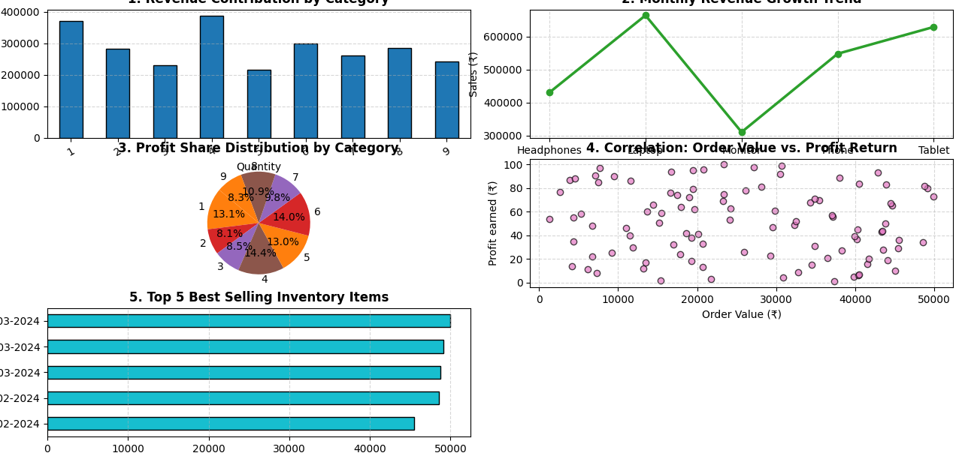
7. CONCLUSION & EXECUTIVE FINDINGS
Based on the multi-dimensional charts and compiled metrics generated by the pipeline, the following strategic insights have been uncovered:
- Profit Optimization: A clear correlation is evident between higher-tier category purchases and net margin returns, suggesting that marketing campaigns should focus heavily on the top-performing categories identified in Chart 1 and Chart 3.
- Operational Health: The business maintains a strong Net Profit Margin of 15%, indicating healthy operational performance. Inventory levels should be adjusted dynamically to align with the peak sales periods identified in the Monthly Sales Trend line chart.

